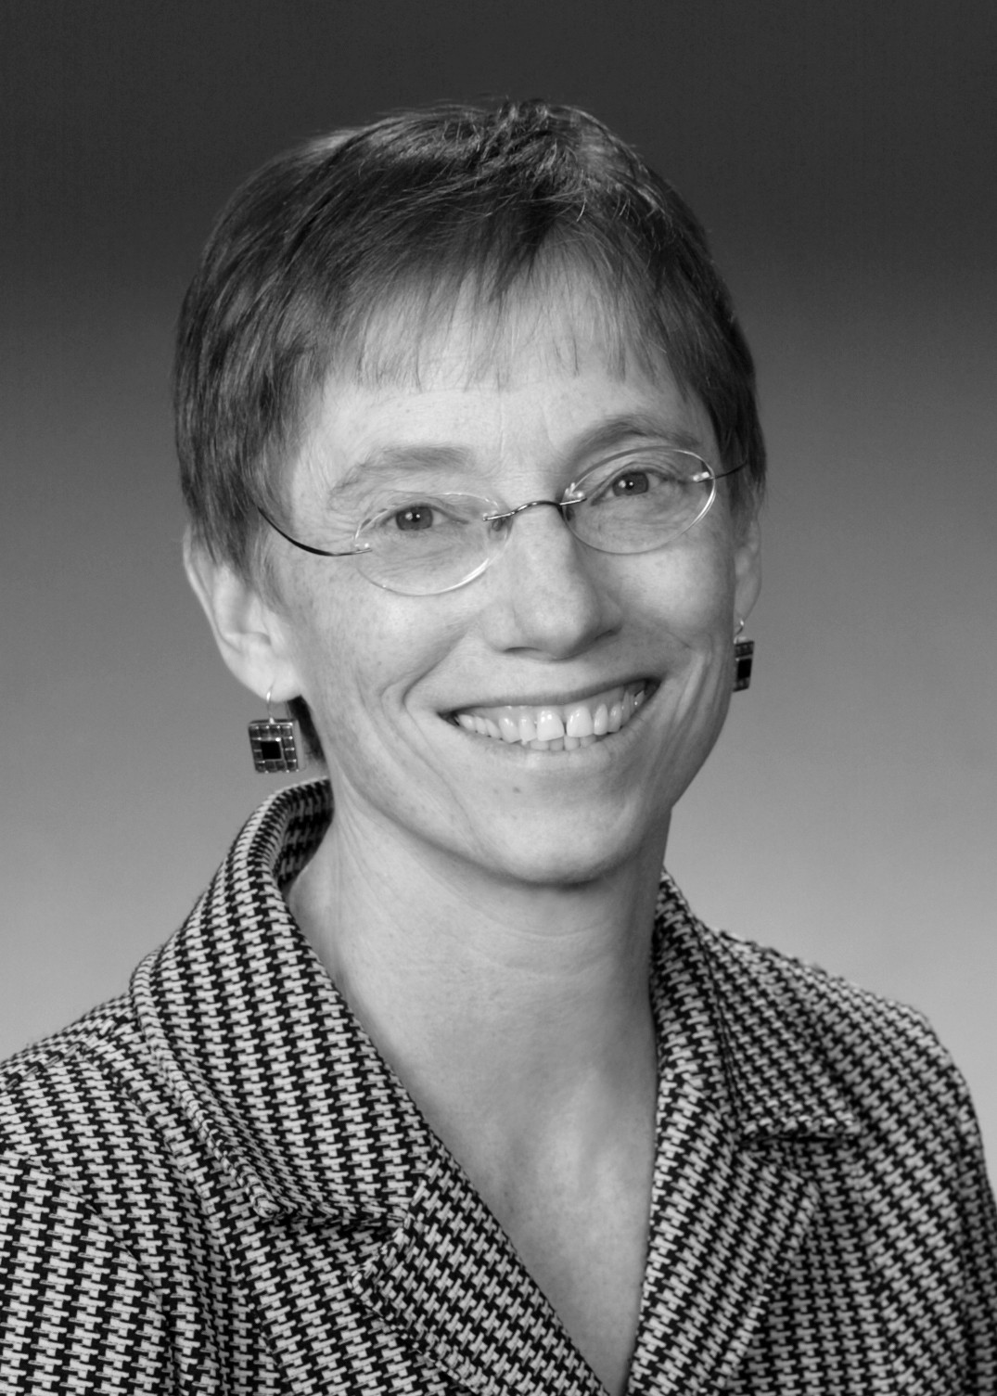
PATRICIA AUFDERHEIDE
University Professor and Director, Center for Social Media
School of Communication, American University

Washington, DC 20016-8017
(202) 885-2069 (o)/ (240) 643-4805 (c)/(301) 942-1082

paufder@american.edu
www.centerforsocialmedia.org

EDUCATION
Ph.D., 1976, University of Minnesota, history
M.A., 1973, University of Minnesota, history
B.A. summa cum laude, 1969, University of Minnesota, history

RECENT HONORS AND AWARDS
Woman of Vision (Career Achievement) Award, Women in Film and Video (DC), October 2010
Communication Research as an Agent of Change Award, International Communication Association, June 2010
Career Achievement Award, International Digital Media and Arts Association, 2008
Preservation and Scholarship Award, International Documentary Association, 2006
Annual Spry Lecturer on Public Broadcasting, Vancouver and Montreal, Canada, November 14- 16, 2006
Scholar-Teacher of the Year, American University, 2004-2005
Finalist and prizewinner, Award for Social and Ethical Relevance in Communication Policy Research, McGannon Center, Fordham University, July, 2000
Fulbright Research Fellowship, 1995
John Simon Guggenheim Memorial Fellowship, 1994
University Award for Outstanding Scholarship, American University, 1994
Association for Education in Journalism and Mass Communication Teaching Standards Committee award, Free Expression Contest, 1991

RECENT EMPLOYMENT HISTORY
2009-present University Professor, American University
2001-present Director and Founder, Center for Social Media, American University
1998-2009 Professor, School of Communication, American University
1994-1998 Associate Professor, School of Communication, American University

1995-1996 Visiting Research Professor, University of Brasília
1989-1994 Assistant Professor, School of Communication, American University
1985-1987 Visiting Professor, Center for International Studies, Duke University
1986-1987 Policy analyst, United Church of Christ, Office of Communication
1982-1983 Senior editor, American Film magazine
1980 Visiting Professor, History, University of Illinois Chicago Circle
1978-present Cultural/senior editor, In These Times newspaper
1976-1978 Assistant Professor, History, University of Minnesota

RECENT PUBLICATIONS
Recent Books/ Monographs
Reclaiming Fair Use: How to Bring Balance Back to Copyright. University of Chicago Press, 2011, with Peter Jaszi.
Documentary Film: A Very Short Introduction. Oxford University Press, 2007.
The Daily Planet. Minneapolis, MN: University of Minnesota Press, 2000.
Communications Policy and the Public Interest: The Telecommunications Act of 1996. New York: Guilford Press, Jan. 1999.
Council on Foundations Film Festival Catalog, 1997-2006. Washington, D.C., Council on Foundations.

Recent Academic Publications
Copyright in the Participatory and Online Video Environment, in Handbook on Participatory Video (eds. Elisabeth-Jane Milne and Claudia Mitchell), Lanham, MD: AltaMira (Accepted January 2012)
Creativity, Copyright and Authorship, in Media Authorship (eds. David Gerstner and Cynthia Chris), New York: Routledge (Accepted January 2012)
Copyright and Fair Use in Mobile Learning, in Handbook of Mobile Learning (eds. Zane Berge and Lin Muilenburg), New York: Taylor and Francis (Accepted November 2011)
Code of Best Practices in Fair Use for Academic and Research Libraries, Washington, DC: Association of Research Libraries; Center for Social Media; Program on Information Justice and Intellectual Property, Washington College of Law, 2012
Copyright, Fair Use and Social Networks in Zizi Papacharisi, The Networked Self: Identity, Community and Culture. New York: Routledge, 2011
With Matthew Nisbet, “Best Practices in Digital Journalism,” Mass Communication and Society, 2011
Expanding the utility of fair use in copyright: the best practices model. Amsterdam: Amsterdam Law Review, 2011
Fair Use in Online Video. I/S Symposium, Ohio University Law Journal, 6(1), 2010, 13-40.
With Mridu Chandra and Peter Jaszi, Honest Truths: Documentary Filmmakers on Ethical Challenges in Their Work, Center for Social Media, 2009
With Jessica Clark, Public Media 2.0: Dynamic, Engaged Publics,.Center for Social Media, 2009
With Peter Jaszi and Lindsay Weeramuni, Code of Best Practices in Fair Use for OpenCourseWare, Center for Social Media, 2009
With Jessica Clark, Will Public Media Survive Where Mainstream Media Failed?, in "The American Prospect," 2009.
With Peter Jaszi, Code of Best Practices in Fair Use for Online Video, Center for Social Media, July 2008
With Peter Jaszi and Renee Hobbs, The Cost of Copyright Confusion for Media Literacy, Center for Social Media, September 2007
The Deep Structures of Democracy: The Nexus of Communications Policy and Public Culture,” in Media cultures, eds. William Urricchio and Susanne Kinnebrock, Universitatsverlag: Heidelberg, Germany, Winter 2006, pp. 15-21
Co-producer with Peter Jaszi, Documentary Filmmakers’ Statement of Best Practices in Fair Use, Center for Social Media, November 2005

Recent Reference Work
“Documentary film, 1990-present,” Blackwell’s Dictionary of Film, 2012
“Television, public service broadcasting, public interest mandates—US,” in Douglas Gomery and Luke Hockley, eds., Television Industries, BFI Publishing, British Film Institute: London, 2006, 45-47
“US Public TV,” in Douglas Gomery and Luke Hockley, eds., Television Industries, BFI Publishing, British Film Institute: London, 2006, p. 48
“Public Television," in Horace Newcomb, ed. Encyclopedia of Television, 1997

EDITORIAL BOARDS
Kartemquin Films, board of directors, 2007-present
Independent Television Service, member of the board of directors, 2000-2007
Editorial boards, Journal of Broadcasting & Electronic Media, 2000-2004; Communication Law and Policy, 2001-present
Editorial board member, Critical Media Studies: Institutions, Politics, and Theory (book series), Rowan & Littlefield, 2000-present
Film Advisory Committee member, National Gallery of Art, 1987-present

